PRACTICAL SKILLS EXAMINATION
DRIVER OPERATOR AERIAL
State Form 52366 (R/11-05)


STATE OF INDIANA

JOB PERFORMANCE REQUIREMENT

SKILLS EVALUATION SYSTEM

CANDIDATE: _____________________________________

EVALUATOR: ____________________________________

DATE: __________ COURSE NUMBER: ______________

LOCATION: ______________________________________

OBJECTIVE:
The Job Performance Requirement Skills Evaluation System is divided into Skill Stations based upon the subject headings within the certification standard. Each of the skill stations are further broken down into Skills Tests which are drawn from each component of the standard. This is an “Evaluation and not a “Training Session”. The candidate must satisfactorily pass each skill.

INSTRUCTORS AND EVALUATORS:
Each Skill Test presented within this Skill Packet is based upon Job Performance Requirements identified by The National Fire Protection Agency and approved by the Indiana Board of Firefighting Personnel Standards and Education. Instructor II/III whom, is serving as the Lead Instructor and/or Lead Evaluator are mandated to ensure the Evaluation and Testing Results satisfy the Job Performance Requirement as described by the standard.

CANDIDATES:
If the candidate is unable to perform a task, the Evaluator will identify the specific task as a “Recommended Area for Further Training.” Each Candidate shall advise the Evaluator when they have completed each Skill Station. Candidates will not find out the results of an individual Skill Station until all evaluations scheduled for that day have been completed. Candidates have the option to retake any Skill Test at the end of the Evaluation Session or during a make-up session scheduled by the Instructor.
Candidate: |  |  |  | Date:
SS#:
Standard: 6.1.1  NFPA 1002, 2003 Edition |  |  | Task: Perform the routine test, inspections, and servicing functions specified in the following list in addition to those specified in the list 6.1.1, given a fire department aerial apparatus, so that the operational readiness of the aerial apparatus is verified.
Performance Outcome: The ability to use hand tools, recognize system problems, and correct any deficiency noted according to policy and procedures. Perform a visual and/or operational aerial device inspection according to the fire departments SOP’s.
Conditions: Manufacturers specifications and requirements, policies, and procedures of the jurisdiction. The aerial operator will complete all elements of the assigned task.
Equipment Required: A fully equipped fire department aerial apparatus, the appropriate equipment to complete the assigned task and access to the departments policies, and procedures.
No. | Task Steps |  |  |  | First Test |  |  | Retest
No. |  |  |  |  | Pass |  | Fail | Pass | Fail
1. | Hydraulic fluid.
2. | Inspect stabilizers.
3. | Inspect turntable assembly.
4. | Inspect lower control pedestal(s). (if applicable)
5. | Inspect the platform control console. (if applicable)
6. | Inspect aerial device communication system.
7. | Status/operation of the breathing air supply system. (if applicable)
8. | Inspect aerial device extension/retraction system.
9. | Inspect elevation /lifting cylinders.
10. | Inspect elevating platform assembly. (if applicable)
11. | Inspect the aerial ladder sections (fly, mid(s), base).
12. | Inspect ladder rungs.
13. | Inspect aerial waterway.
14. | Inspect all equipment attached to any portion of the aerial device or ladder sections.

Reference: IFSTA Aerial Apparatus Driver/Operator Handbook 1st Edition

Lead Evaluator/Candidate Comments:

Lead Evaluator (Print & Sign) Date Candidate Date

Re-Test Lead Evaluator Date Re-Test Candidate Date
Candidate: |  |  |  | Date:
SS#:
Standard: 4.3.1  NFPA 1002, 2003 Edition |  |  | Task: Operate a fire department aerial apparatus over a predetermined route on a public way that incorporates the maneuvers and features specified in the list in 4.3.1, so that the vehicle is safely operated in compliance with all applicable state and local laws, department rules and regulations, and the requirements of NFPA 1500, Standard on Fire Department Occupational Safety and Health Program, Section 4.2.
Performance Outcome: The candidate will safely complete the task operating the department pumper on a predetermined route provided by the Authority Having Jurisdiction.

The AHJ will administer this JPR prior to the candidate participating in the Driver/Operator Practical.

Conditions: The candidate will complete all elements of the assigned task.
Equipment Required: (1) one fire department aerial apparatus.
No. | Task Steps |  |  |  | First Test |  |  | Retest
No. |  |  |  |  | Pass |  | Fail | Pass | Fail
1. | Four left turns.
2. | Four right turns.
3. | A straight section of urban business street or a two-lane rural road at least 1 mile in length.
4. | One through-intersection and two intersections where a stop has to be made.
5. | One Railroad crossing.
6. | One curve, either left or right.
7. | A section of limited-access highway that includes a conventional ramp entrance and exit and a section of road long enough to allow two lane changes.
8. | A downgrade steep enough and long enough to require down-shifting and braking.
9. | An upgrade steep enough and long enough to require gear changing to maintain speed.
10. | One underpass or a low clearance or bridge.

Reference: IFSTA Aerial Apparatus Driver/Operator Handbook 1st Edition

A-4.3.2
The maneuvers and features specified for this JPR include driving situations that the committee has determined to be essential. The committee recognizes that each of these situations might not exist in all areas. Where this occurs, those specific requirements can be omitted.

Lead Evaluator/Candidate Comments:

Lead Evaluator (Print & Sign) Date Candidate Date

Re-Test Lead Evaluator Date Re-Test Candidate Date
Candidate: |  |  |  | Date:
SS#:
Standard: 5.1  NFPA 1002, 2003 Edition |  |  | Task: The aerial apparatus driver/operator, given a fire department aerial apparatus, shall demonstrate ability to prepare the pumper to be driven.
Performance Outcome: Preliminary Apparatus Inspection
Conditions: The candidate will complete all elements of the assigned task.
Equipment Required: (1) one fire department aerial apparatus.
No. | Task Steps |  |  |  | First Test |  |  | Retest
No. |  |  |  |  | Pass |  | Fail | Pass | Fail
1. | Check and adjust the drivers’ seat.
2. | Check and adjust vehicle mirrors.
3. | Fasten seatbelt prior to placing the pumper in motion.

Reference: IFSTA Aerial Apparatus Driver/Operator Handbook 1st Edition

Lead Evaluator/Candidate Comments:

Lead Evaluator (Print & Sign) Date Candidate Date

Re-Test Lead Evaluator Date Re-Test Candidate Date
Candidate: |  |  |  | Date:
SS#:
Standard: 4.3.6  NFPA 1002, 2003 Edition |  |  | Task: Operate a vehicle using defensive driving techniques under emergency conditions, given a fire department vehicle and emergency conditions, so that control of the vehicle maintained.
Performance Outcome: The ability to operate passenger restraint devices, maintain safe following distances, maintain control of the vehicle while accelerating, decelerating, and turning, maintain reasonable speed for road, weather, and traffic conditions, operate safely during non-emergency conditions, operate under adverse environmental or driving surface conditions, and use automotive gauges and controls. The Authority Having Jurisdiction will administer this JPR prior to the candidate participating in the Driver/Operator Practical.
Conditions: The candidate will complete all elements of the assigned task.
Equipment Required: A fire department vehicle, the appropriate equipment to complete the assigned tasks and access to department policies, procedures and related forms.
No. | Task Steps |  |  |  | First Test |  |  | Retest
No. |  |  |  |  | Pass |  | Fail | Pass | Fail
1. | Wear seatbelt.
2. | Operate passenger restraint devices.
3. | Maintain safe following distances.
4. | Maintain control of the vehicle while accelerating, decelerating, and turning.
5. | Maintain reasonable speed for road, weather, and traffic conditions.
6. | Operate safely during non-emergency conditions.
7. | Operate under adverse environmental or driving surface conditions.
11. | Use automotive gauges and controls.

*Authority Having Jurisdiction will make available to the proctor any documentation to verify that these duties have been performed.

Reference: IFSTA Aerial Apparatus Driver/Operator Handbook 1st Edition

Lead Evaluator/Candidate Comments:

Lead Evaluator (Print & Sign) Date Candidate Date

Re-Test Lead Evaluator Date Re-Test Candidate Date
Candidate: |  |  |  | Date:
SS#:
Standard: 4.3.2  NFPA 1002, 2003 Edition |  |  | Task: Perform the practical driving exercises specified 4.3.2 through 4.3.5 given a fire department aerial apparatus and a spotter for backing, so that each exercise is performed safely without striking the vehicle or obstructions.
Performance Outcome: 4.3.2* Back a vehicle from a roadway into restricted spaces on both the right and left sides of the vehicle, given a fire department vehicle, a spotter, and restricted spaces 12 ft in width, requiring 90-degree right-hand and left-hand turns from the roadway, so that the vehicle is parked within the restricted areas without having to stop and/or pull forward and without striking obstructions.
(Alley Dock Exercise)
Conditions: The candidate will complete all elements of the assigned task.
Equipment Required: (1) one fire department aerial apparatus.
No. | Task Steps |  |  |  | First Test |  |  | Retest
No. |  |  |  |  | Pass |  | Fail | Pass | Fail
1. | Back the aerial apparatus into restricted space on the right side without having to stop and/or pull forward and without striking obstructions.
2. | Back the aerial apparatus into restricted space on the left side without having to stop and/or pull forward and without striking obstructions.
3. | Do not allow the pumper to leave course boundaries.

See attached NFPA Appendix & Figure A-4.3.2 (a) & (b) for instructions and dimensions.

NOTE: JPR is complete upon backing into the dock exercise; the candidate will not be evaluated while pulling out of the dock area.

Reference: IFSTA Aerial Apparatus Driver/Operator Handbook 1st Edition

Lead Evaluator/Candidate Comments:

Lead Evaluator (Print & Sign) Date Candidate Date

Re-Test Lead Evaluator Date Re-Test Candidate Date

A-4.3.2
The alley dock exercise can be used as practice for or in the evaluation of this requirement. This exercise measures a driver’s ability to drive past a simulated dock or stall, back the apparatus into the space provided, and stop smoothly. A dock or stall can be simulated by arranging barricades 40 ft (12.2 m) from a boundary line. These barricades should be 12 ft (3.66 m) apart, and the length should be approximately 20 ft (6.1 in). The driver should pass the barricades with the dock on the left and then back the apparatus, using a left turn, into the stall. The exercise should then be repeated with the dock on the right side, using a right turn. [See Figure A-4.3.2(a).]

The apparatus station parking maneuver can also be used as practice for or in the evaluation of this requirement. This exercise measures the driver’s ability to back the apparatus into a fire station to park or to back the apparatus down a street to reverse the direction of travel. An engine bay can be simulated by allowing for a 20-ft (6.1-rn) minimum setback from a street 30 ft (9 m) wide, with a set of barricades at the end of the setback, spaced 12 ft (3.66 m) apart to simulate the garage door. The setback from the street should be determined by the testing agency to ensure that the distances reflect those encountered by the apparatus driver during the normal course of duties.
A marker placed on the ground should indicate to the operator the proper position of the left front tire of the vehicle once stopped and parked. A straight line can be provided to assist the operator while backing the apparatus, facilitating the use of vehicle mirrors. The minimum depth distance is determined by the total length of the vehicle. [See Figure A-4.3.2(b).]

NOTE: For large vehicles, such as ARFF apparatus, this course might need to be modified.

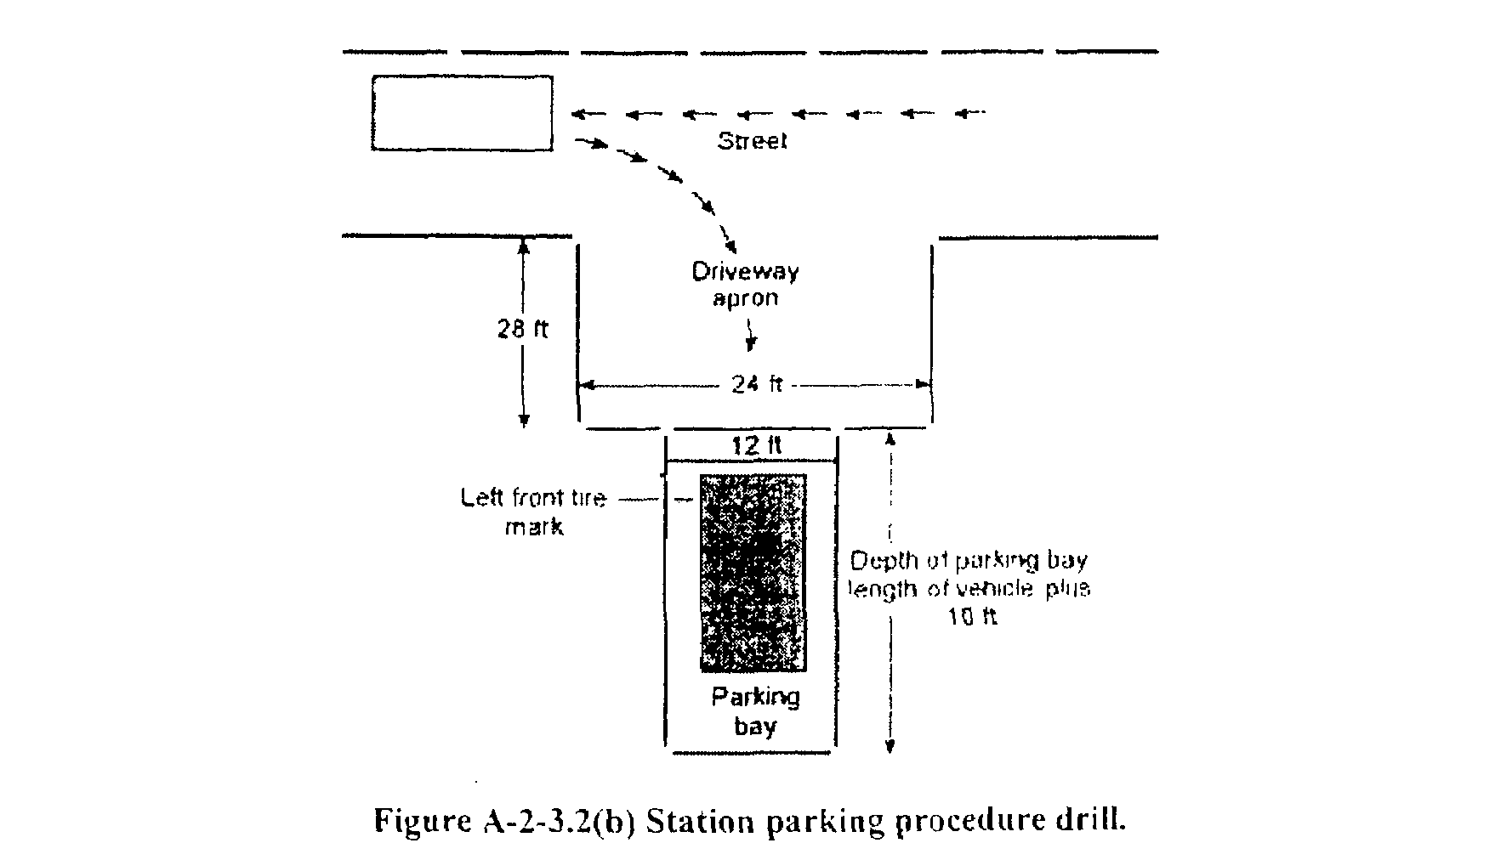

Copyright NFPA

Candidate: |  |  |  | Date:
SS#:
Standard: 4.3.3  NFPA 1002, 2003 Edition |  |  | Task: Perform the practical driving exercises specified 4.3.2 through 4.3.5 given a fire department aerial apparatus and a spotter for backing, so that each exercise is performed safely without striking the vehicle or obstructions..
Performance Outcome: 4.3.3* Maneuver a vehicle around obstructions on a roadway while moving forward and in reverse, given a fire department vehicle, spotter for backing, and a roadway for obstructions, so that the vehicle is maneuvered through the obstacle without stopping and/or changing the direction of travel and without striking the obstructions.
(Serpentine Exercise)
Conditions: The candidate will complete all elements of the assigned task.
Equipment Required: (1) one fire department aerial apparatus.
No. | Task Steps |  |  |  | First Test |  |  | Retest
No. |  |  |  |  | Pass |  | Fail | Pass | Fail
1. | Maneuver the aerial apparatus forward around obstructions without stopping and/or changing direction of travel and without striking obstructions.
2. | Maneuver the aerial apparatus in reverse around obstructions without stopping and/or changing direction of travel and without striking obstructions.
3. | Do not allow the pumper to leave course boundaries.

See attached NFPA Appendix & Figure A-4.3.3 for instructions and dimensions.

NOTE: Course boundaries are 20 feet from center of cone on each side. Total width of 40 feet.

Reference: IFSTA Aerial Apparatus Driver/Operator Handbook 1st Edition

Lead Evaluator/Candidate Comments:

Lead Evaluator (Print & Sign) Date Candidate Date

Re-Test Lead Evaluator Date Re-Test Candidate Date

A-4.3.3
The serpentine exercise can be used as practice for or in the evaluation of this requirement. This exercise measures a driver’s ability to steer the apparatus in close limits without stopping. The exercise should be conducted with the apparatus moving first backward, then forward. The course or path of travel for this exercise can be established by placing a minimum of three markers, each spaced between 30 ft (9 m) and 38 ft (12 m) apart, in a line. The spacing of the markers should be based on the wheel base of the vehicle used. Adequate space must be provided on each side of the markers for the apparatus to move freely. The driver should drive the apparatus along the left side of the markers in a straight line and stop just beyond the last marker. The driver then should back the apparatus between the markers by passing to the left of marker No. 1, to the right of marker No. 2, and to the left of marker No. 3. At this point, the driver should stop the vehicle and then drive it forward between the markers by passing to the right of marker No. 3, to the left of marker No. 2, and to the right of marker No. 1. (See Figure A-4.3.3.)

NOTE: For large vehicles, such as ARFF apparatus, this course might need to be modified.

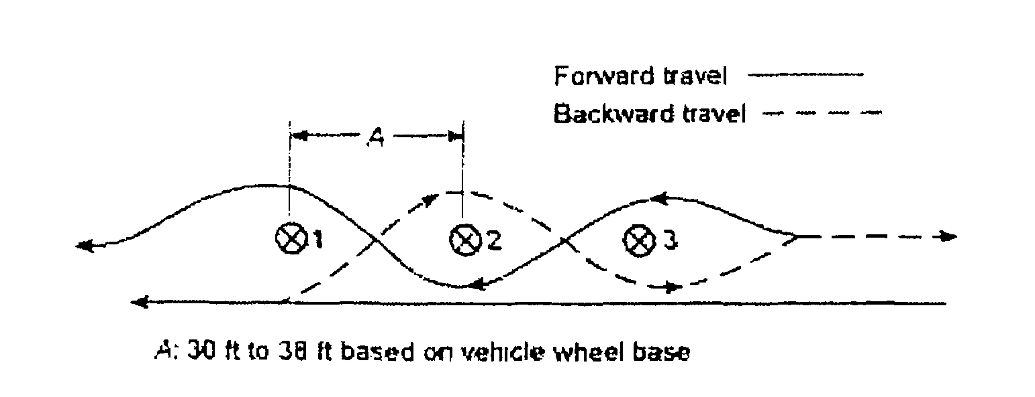
Figure A-4.3.3 Serpentine exercise.

NOTE: Use 36 feet for Driver Operator Pumper (based on a standard wheel base of 16feet overall length of 32 feet. If pumper is longer adjust length as referenced above.)
NOTE: For large vehicles, such as ARFF apparatus, this course might need to be modified.

Copyright NFPA

Candidate: |  |  |  | Date:
SS#:
Standard: 4.2.4  NFPA 1002, 2003 Edition |  |  | Task: Perform the practical driving exercises specified 4.3.2 through 4.3.5 given a fire department aerial apparatus and a spotter for backing, so that each exercise is performed safely without striking the vehicle or obstructions.
Performance Outcome: 4.3.4* Turn a fire department vehicle 180 degrees within a confined space, given a fire department vehicle, a spotter for backing, and an area in which the vehicle cannot perform a U-turn without stopping and backing up, so that the vehicle is turned 180 degrees without striking obstructions within the given space.
(Turn Around Exercise)
Conditions: The candidate will complete all elements of the assigned task.
Equipment Required: (1) one fire department aerial apparatus.
No. | Task Steps |  |  |  | First Test |  |  | Retest
No. |  |  |  |  | Pass |  | Fail | Pass | Fail
1. | Turn the aerial apparatus 180 degrees within a confined space, without striking obstructions.
2. | Do not allow the aerial apparatus to leave course boundaries.

See attached NFPA Appendix & Figure A-4.3.4 for instructions and dimensions.

Reference: IFSTA Aerial Apparatus Driver/Operator Handbook 1st Edition

Lead Evaluator/Candidate Comments:

Lead Evaluator (Print & Sign) Date Candidate Date

Re-Test Lead Evaluator Date Re-Test Candidate Date

A-4.3.4
The confined space turnaround can be used as practice for or in the evaluation of this requirement. This exercise measures the driver’s ability to turn the vehicle around in a confined space without striking obstacles. The turn is accomplished within an area 50 ft x 100 ft (15.25 m x 30.5 in). The driver moves into the area from a 14.ft (3.66-rn) opening in the center of one of the 50-ft (15.25-rn) legs, turns the vehicle 180 degrees, and returns through the opening. There is no limitation on the number of times the driver has to maneuver the vehicle to accomplish this exercise, but no portion of the vehicle should extend over the boundary lines of the space. (See Figure A-4.3. 4.)

NOTE: For large vehicles, such as ARFF apparatus, this course might need to be modified.

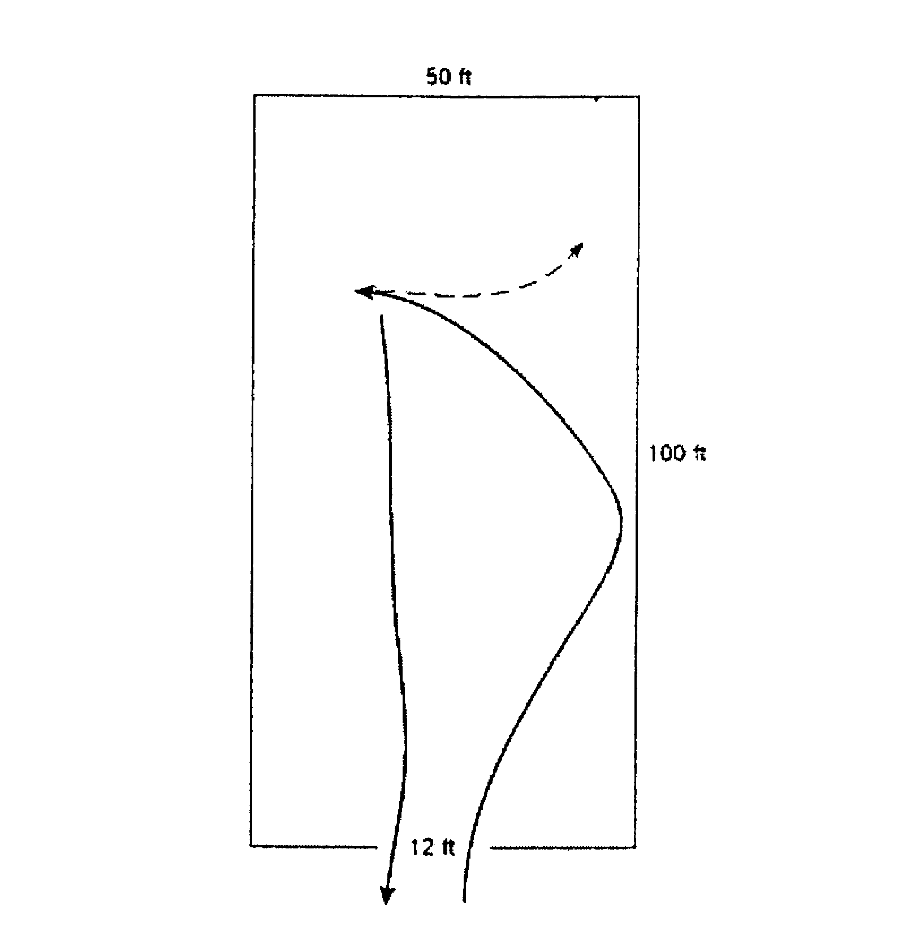

Figure A-4.3.4 Confined space turnaround.

Copyright NFPA

Candidate: |  |  |  | Date:
SS#:
Standard: 4.3.5  NFPA 1002, 2003 Edition |  |  | Task: Perform the practical driving exercises specified 4.3.2 through 4.3.5 given a fire department aerial apparatus and a spotter for backing, so that each exercise is performed safely without striking the vehicle or obstructions.
Performance Outcome: 4.3.5* Maneuver a fire department vehicle in areas with restricted horizontal and vertical clearances, given a fire department vehicle and a course that requires the operator to move forward through areas of restricted horizontal and vertical clearances, so that the operator accurately judges the ability of the vehicle to pass through the openings and so that no obstructions are struck.
(Diminishing Clearance Exercise)
Conditions: The candidate will complete all elements of the assigned task.
Equipment Required: (1) one fire department aerial apparatus.
No. | Task Steps |  |  |  | First Test |  |  | Retest
No. |  |  |  |  | Pass |  | Fail | Pass | Fail
1. | Maneuver the aerial apparatus forward through the diminishing clearance exercise without striking obstructions.
2. | Do not allow the aerial apparatus to cross over the finish line.

See attached Appendix and Figure A-4.3.5 for instructions and dimensions.

NOTE: Not all apparatus will fit in dimensions given below. Proctor should measure wheel width of apparatus to be used in the course to include tire bulge, add 2” to the total width of the course (1” on each side)

Reference: IFSTA Aerial Apparatus Driver/Operator Handbook 1st Edition

Lead Evaluator/Candidate Comments:

Lead Evaluator (Print & Sign) Date Candidate Date

Re-Test Lead Evaluator Date Re-Test Candidate Date

A-4.3.5
The diminishing clearance exercise can be used as practice for or in the evaluation of this requirement. This exercise measures a driver’s ability to steer the apparatus in a straight line, to judge distances from wheel to object, and to stop at a finish line. The speed at which a driver should operate the apparatus is optional, but it should be great enough to necessitate quick judgment. The course for this exercise is created by arranging two rows of markers to form a lane 75 ft (22.9 m) long. The lane varies in width from 9 ft 6 in. (2.9 m) to a diminishing clearance of 8 ft 2 in. (2.5 in). The driver should maneuver the apparatus forward through this lane without touching the markers. The vehicle should be stopped at a finish line 50 ft (15.25 in) beyond the last marker. No portion of the vehicle should protrude beyond this line. (See Figure A-4.3.5.)

NOTE: For large vehicles, such as ARFF apparatus, this course might need to be modified.

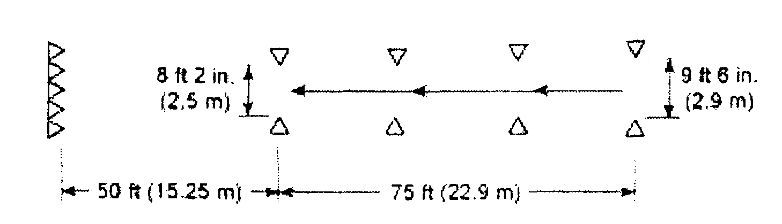

Figure A-4.3.5 Diminishing clearance exercise.

Copyright NFPA

Candidate: |  |  |  | Date:
SS#:
Standard: 6.2.2  NFPA 1002, 2003 Edition |  |  | Task: Stabilize an aerial apparatus, given a properly positioned vehicle and the manufacturer’s recommendations, so the power can be transferred to the aerial device hydraulic system and the device can be safely deployed.
Performance Outcome: The ability to transfer power from the vehicles engine to the hydraulic system and operate vehicle stabilization devices.
Conditions: Aerial apparatus hydraulic systems, manufacture’s specification stabilization requirements, and effects of topography and ground condition on safe stabilization. The aerial operator will complete all elements of the assigned task.
Equipment Required: A fully equipped fire department aerial apparatus, the appropriate equipment to complete the assigned task and access to department policies, and procedures.
No. | Task Steps |  |  |  | First Test |  |  | Retest
No. |  |  |  |  | Pass |  | Fail | Pass | Fail
1. | Ensure the apparatus placement is appropriate for the assigned task.
2. | Set the parking brake.
3. | Place transmission selector in the appropriate gear recommended by the manufacturer.
4. | Activate the PTO system.
5. | Place the transmission selector in the appropriate gear recommended by the manufacture for the assigned task.
6. | Check for overhead obstructions and ensure proper apparatus placement.
7. | Chock both in front of and behind the tire, of the appropriate wheel(s) on both sides of the apparatus. (Based on manufacturer’s recommendation)
8. | Check the expected travel path of the stabilizers for obstructions and/or limiting factors.
9. | Check the ground surface for stability and proper conditions.
10. | Deploy and properly place the stabilizer ground pads.
11. | Properly deploy the stabilizers.
12. | Raise the apparatus to its working position, as close to level as possible.
13. | Lock the stabilizers by manufacturer’s recommendations (holding valves, interlock feature, safety pins, or combination of features).

Continue to next JPR Sheet without shutting down

Reference: IFSTA Aerial Apparatus Driver/Operator Handbook 1st Edition

Lead Evaluator/Candidate Comments:

Lead Evaluator (Print & Sign) Date Candidate Date

Re-Test Lead Evaluator Date Re-Test Candidate Date
Candidate: |  |  |  | Date:
SS#:
Standard: 6.2.3  NFPA 1002, 2003 Edition |  |  | Task: Maneuver and position the aerial device from each control station, given an incident location, a situation description, and an assignment, so that the aerial device is properly positioned to safely accomplish the assignment.
Performance Outcome: The ability to raise, rotate, extend, and position to a specified location and ability lock, unlock, retract, lower, and bed the aerial device. The aerial apparatus operator will properly raise and position the aerial device to perform a victim rescue from the window of the ____ floor of a multiple story building on the ____ side. The wind is out of the ____ at ____mph.
Conditions: Knowledge of aerial device hydraulic systems, hydraulic pressure relief systems, gauges and controls, cable systems, communication systems, electrical systems, emergency operating systems, locking systems, manual rotation and lowering systems, system overrides, safe operation limitations of the given aerial device, safety procedures specific to the device, and operations near electrical hazards and overhead obstructions. The candidate will complete all assigned tasks.
Equipment Required: A fully equipped fire department aerial apparatus, the appropriate equipment to complete the assigned task and access to department policies, and procedures.
No. | Task Steps |  |  |  | First Test |  |  | Retest
No. |  |  |  |  | Pass |  | Fail | Pass | Fail
1. | Release the hold down locks. (if applicable)
2. | Ensure all safety devices are in place and are properly used by the operator. (slide-out platforms, safety chains, guardrails, dead-man switches, etc)
3. | Check the intended path of the aerial device for obstructions. (overhead, ladder cradle, cabinetry, accessories, personnel, etc)
4. | Elevate - the aerial device in a safe, smooth, efficient operation using the correct engine speed for the application to the desired height for the intended target.
5. | Rotate - the aerial device in a safe, smooth, efficient operation using the correct engine speed for the application until the tip of the device is inline with the intended target.
6. | Extend - the aerial device in a safe, smooth, efficient operation using the correct engine speed for the application slightly above the intended target.
7. | Lower - the aerial device to the objective according to department SOP’s and manufacturers specifications.
8. | Align aerial device ladder rungs.
9. | Refers to aerial load chart for proper ladder and tip loads.
10. | Clears firefighters to safely climb the aerial ladder.

Continue to next JPR Sheet without shutting down

Reference: IFSTA Aerial Apparatus Driver/Operator Handbook 1st Edition

Lead Evaluator/Candidate Comments:

Lead Evaluator (Print & Sign) Date Candidate Date

Re-Test Lead Evaluator Date Re-Test Candidate Date
Candidate: |  |  |  | Date:
SS#:
Standard: 6.2.3  NFPA 1002, 2003 Edition |  |  | Task: Maneuver and position the aerial device from each control station, given an incident location, a situation description, and an assignment, so that the aerial device is properly positioned to safely accomplish the assignment.
Performance Outcome: The ability to raise, rotate, extend, and position to a specified location and ability lock, unlock, retract, lower, and bed the aerial device. The aerial device operator will properly raise and position the aerial device to perform roof operations. The aerial device will be positioned on the ____ side of a multiple story building allowing firefighters to carry and/or deliver equipment to the roof for ventilation.
Conditions: Knowledge of aerial device hydraulic systems, hydraulic pressure relief systems, gauges and controls, cable systems, communication systems, electrical systems, emergency operating systems, locking systems, manual rotation and lowering systems, system overrides, safe operation limitations of the given aerial device, safety procedures specific to the device, and operations near electrical hazards and overhead obstructions. The candidate will complete all assigned tasks.
Equipment Required: A fully equipped fire department aerial apparatus, the appropriate equipment to complete the assigned task and access to department policies, and procedures.
No. | Task Steps |  |  |  | First Test |  |  | Retest
No. |  |  |  |  | Pass |  | Fail | Pass | Fail
1. | Release the hold down locks. (if applicable)
2. | Ensure all safety devices are in place and are properly used by the operator (slide-out platforms, safety chains, guardrails, dead-man switches, etc).
3. | Check the intended path of the aerial device for obstructions (overhead, ladder cradle, cabinetry, accessories, personnel, etc).
4. | Elevate - the aerial device in a safe, smooth, efficient operation using the correct engine speed for the application to the desired height for the intended target.
5. | Rotate - the aerial device in a safe, smooth, efficient operation using the correct engine speed for the application until the tip of the device is inline with the intended target.
6. | Extend - the aerial device in a safe, smooth, efficient operation using the correct engine speed for the application slightly above the intended target.
7. | Lower - the aerial device to the objective according to department SOP’s and manufacturers specifications.
8. | Align aerial device ladder rungs.
9. | Refers to aerial load chart for proper ladder and tip loads.
10. | Clears firefighters to safely climb the aerial ladder.

Continue to next JPR Sheet without shutting down

Reference: IFSTA Aerial Apparatus Driver/Operator Handbook 1st Edition

Lead Evaluator/Candidate Comments:

Lead Evaluator (Print & Sign) Date Candidate Date

Re-Test Lead Evaluator Date Re-Test Candidate Date
Candidate: |  |  |  | Date:
SS#:
Standard: 6.2.5  NFPA 1002, 2003 Edition |  |  | Task: Deploy and operate an elevated master stream, given a master stream device and a desired flow, so that the stream is effective and the device is operated safely.
Performance Outcome: The ability to connect a water supply to a master stream device and control an elevated nozzle manually or remotely. The aerial apparatus operator will first explain and demonstrate the proper procedures to manually operate the nozzle on the waterway. After connecting an adequate water supply, the aerial operator will demonstrate the proper procedures to safely raise the aerial device and position the waterway to flow _____ gpm using a _____ inch smooth bore nozzle/fog nozzle, _____ feet in elevation with the ladder extended to _____ feet in a defensive firefighting mode. The aerial operator must calculate and flow the correct pump pressure for the situation described.
Conditions: Nozzle reaction, range of motion, and weight limitations. The candidate will complete all assigned tasks.
Equipment Required: A fully equipped fire department aerial apparatus, the appropriate equipment to complete the assigned task and access to department policies, and procedures.

Continue to next JPR Sheet without shutting down

Reference: IFSTA Aerial Apparatus Driver/Operator Handbook 1st Edition

Lead Evaluator/Candidate Comments:

Lead Evaluator (Print & Sign) Date Candidate Date

Re-Test Lead Evaluator Date Re-Test Candidate Date
Candidate: |  |  |  | Date:
SS#:
Standard: 6.2.5  NFPA 1002, 2003 Edition |  |  | Task: Deploy and operate an elevated master stream, given a master stream device and a desired flow, so that the stream is effective and the device is operated safely.
Performance Outcome: The ability to connect a water supply to a master stream device and control an elevated nozzle manually or remotely. The aerial apparatus operator will first explain and demonstrate the proper procedures to manually operate the nozzle on the waterway. After connecting an adequate water supply, the aerial operator will demonstrate the proper procedures to safely raise the aerial device and position the waterway to flow _____ gpm using a _____ inch smooth bore nozzle/fog nozzle, _____ feet in elevation with the ladder extended to _____ feet in a defensive firefighting mode. The aerial operator must calculate and flow the correct pump pressure for the situation described.
Conditions: Nozzle reaction, range of motion, and weight limitations. The candidate will complete all assigned tasks.
Equipment Required: A fully equipped fire department aerial apparatus, the appropriate equipment to complete the assigned task and access to department policies, and procedures.
No. | Task Steps |  |  |  | First Test |  |  | Retest
No. |  |  |  |  | Pass |  | Fail | Pass | Fail
1. | Explain and demonstrate how to manually rotate the nozzle from side to side.
2. | Explain and demonstrate how to manually raise and lower the nozzle.
3. | Explain and demonstrate how to manually adjust the spray pattern of the nozzle.
4. | Demonstrate how to change from a fog nozzle to a smooth bore tip with/without a stream straightener. (Select the appropriate nozzle for the assigned task)
5. | Demonstrate how to attach a portable ladder pipe/hose line, or adjust pinable waterway in the appropriate position. (if applicable)
6. | Connect an adequate water supply to the proper water inlet. (as per department SOP’s and manufacturers specifications)
7. | Release the hold down locks. (if applicable)
8. | Ensure all safety devices are in place and are properly used by the operator. (slide-out platforms, safety chains, guardrails, dead-man switches, etc)
9. | Check the intended path of the aerial device for obstructions (overhead, ladder cradle, cabinetry, accessories, personnel, etc).
10 | Elevate - the aerial device in a safe, smooth, efficient operation using the correct engine speed for the application to the desired height for the intended target.
11 | Rotate - the aerial device in a safe, smooth, efficient operation using the correct engine speed for the application until the tip of the device is inline with the intended target.
12 | Extend - the aerial device in a safe, smooth, efficient operation using the correct engine speed for the application.
13 | Refers to aerial load chart for proper ladder and tip loads for water flow.
14 | Smoothly opens waterway discharge valve with minimal stress and movement of the aerial device and waterway.
15 | Discharges the correct gpm for the assigned task at ____ psi pump pressure.
16 | Smoothly closes waterway discharge valve with minimal stress and movement of the aerial device and waterway.
17 | Disengages pump.
18 | Close and disconnect water supply from fire apparatus.
19 | Opens waterway drain to drain waterway pipe completely prior to repositioning the ladder.
20 | Retract, rotate, and lower aerial device.
21 | Disassemble any portable ladder pipe, hoseline, and/or return waterway pin to its stowed position.
22. | Returns the proper nozzle (as per department SOP’s) onto the aerial monitor and places the monitor in its correct stowed position.
23. | Properly bed the aerial device.

Continue to next JPR Sheet without shutting down

Reference: IFSTA Aerial Apparatus Driver/Operator Handbook 1st Edition

Lead Evaluator/Candidate Comments:

Lead Evaluator (Print & Sign) Date Candidate Date

Re-Test Lead Evaluator Date Re-Test Candidate Date
Candidate: |  |  |  | Date:
SS#:
Standard:6.2.5  NFPA 1002, 2003 Edition |  |  | Task: Deploy and operate an elevated master stream, given a master stream device and a desired flow, so that the stream is effective and the device is operated safely.
Performance Outcome: The ability to connect a water supply to a master stream device and control an elevated nozzle manually or remotely. The aerial apparatus operator will first explain and demonstrate the proper procedures to manually operate the nozzle on the waterway. After connecting an adequate water supply, the aerial operator will demonstrate the proper procedures to safely raise the aerial device and position the waterway to flow _____ gpm using a _____ inch smooth bore nozzle/fog nozzle, to the ____ floor window on the ____ side of the building for an offensive/defensive firefighting mode. The aerial operator must calculate and flow the correct pump pressure for the situation described.
Conditions: Nozzle reaction, range of motion, and weight limitations. The candidate will complete all assigned tasks.
Equipment Required: A fully equipped fire department aerial apparatus, the appropriate equipment to complete the assigned task and access to department policies, and procedures.

Continue to next JPR Sheet without shutting down

Reference: IFSTA Aerial Apparatus Driver/Operator Handbook 1st Edition

Lead Evaluator/Candidate Comments:

Lead Evaluator (Print & Sign) Date Candidate Date

Re-Test Lead Evaluator Date Re-Test Candidate Date
Candidate: |  |  |  | Date:
SS#:
Standard:6.2.5  NFPA 1002, 2003 Edition |  |  | Task: Deploy and operate an elevated master stream, given a master stream device and a desired flow, so that the stream is effective and the device is operated safely.
Performance Outcome: The ability to connect a water supply to a master stream device and control an elevated nozzle manually or remotely. The aerial apparatus operator will first explain and demonstrate the proper procedures to manually operate the nozzle on the waterway. After connecting an adequate water supply, the aerial operator will demonstrate the proper procedures to safely raise the aerial device and position the waterway to flow _____ gpm using a _____ inch smooth bore nozzle/fog nozzle, to the ____ floor window on the ____ side of the building for an offensive/defensive firefighting mode. The aerial operator must calculate and flow the correct pump pressure for the situation described.
Conditions: Nozzle reaction, range of motion, and weight limitations. The candidate will complete all assigned tasks.
Equipment Required: A fully equipped fire department aerial apparatus, the appropriate equipment to complete the assigned task and access to department policies, and procedures.
No. | Task Steps |  |  |  | First Test |  |  | Retest
No. |  |  |  |  | Pass |  | Fail | Pass | Fail
1. | Explain and demonstrate how to manually rotate the nozzle from side to side.
2. | Explain and demonstrate how to manually raise and lower the nozzle.
3. | Explain and demonstrate how to manually adjust the spray pattern of the nozzle.
4. | Demonstrate how to change from a fog nozzle to a smooth bore tip with/without a stream straightener. (Select the appropriate nozzle for the assigned task)
5. | Demonstrate how to attach a portable ladder pipe/hose line, or adjust pinable waterway in the appropriate position. (if applicable)
6. | Connect an adequate water supply to the proper water inlet. (as per department SOP’s and manufacturers specifications)
7. | Release the hold down locks. (if applicable)
8. | Ensure all safety devices are in place and are properly used by the operator (slide-out platforms, safety chains, guardrails, dead-man switches, etc).
9. | Check the intended path of the aerial device for obstructions (overhead, ladder cradle, cabinetry, accessories, personnel, etc).
10 | Elevate - the aerial device in a safe, smooth, efficient operation using the correct engine speed for the application to the desired height for the intended target.
11 | Rotate - the aerial device in a safe, smooth, efficient operation using the correct engine speed for the application until the tip of the device is inline with the intended target.
12 | Extend - the aerial device in a safe, smooth, efficient operation using the correct engine speed for the application.
13 | Position proper nozzle placement for the assigned task.
14 | Adjust nozzle angle for the assigned task.
15 | Refers to aerial load chart for proper ladder and tip loads.
16 | Smoothly opens waterway discharge valve with minimal stress and movement of the aerial device and waterway.
17 | Discharges the correct gpm for the assigned task at ____ psi pump pressure.
18 | Smoothly closes the waterway discharge valve with minimal stress and movement of the aerial device and waterway.
19 | Disengages pump.
20 | Close water supply and disconnect water supply from fire apparatus.
21 | Opens waterway drain and drains waterway pipe completely prior to repositioning the ladder.
22 | Retract, rotate, and lower aerial device.
23 | Disassemble any portable ladder pipe, hoseline, and /or return waterway pin to its stowed position. (if applicable)
24 | Returns the proper nozzle (as per department SOP’s) onto the aerial monitor and places the monitor in its correct stowed position.
25. | Properly bed the aerial device.

Continue to next JPR Sheet without shutting down

Reference: IFSTA Aerial Apparatus Driver/Operator Handbook 1st Edition

Lead Evaluator/Candidate Comments:

Lead Evaluator (Print & Sign) Date Candidate Date

Re-Test Lead Evaluator Date Re-Test Candidate Date
Candidate: |  |  |  | Date:
SS#:
Standard: 6.2.3  NFPA 1002, 2003 Edition |  |  | Task: Maneuver and position the aerial device from each control station, given an incident location, a situation description, and an assignment, so that the aerial device is properly positioned to safely accomplish the assignment.
Performance Outcome: The ability to raise, rotate, extend, and position to a specified location and ability lock, unlock, retract, lower, and bed the aerial device. The aerial apparatus operator will properly raise and position the aerial device to perform window ventilation from the _____ window from the left/right of the ____ floor of a multiple story building on the ____ side. The wind is out of the ____ at ____mph.
Conditions: Knowledge of aerial device hydraulic systems, hydraulic pressure relief systems, gauges and controls, cable systems, communication systems, electrical systems, emergency operating systems, locking systems, manual rotation and lowering systems, system overrides, safe operation limitations of the given aerial device, safety procedures specific to the device, and operations near electrical hazards and overhead obstructions. The candidate will complete all assigned tasks.
Equipment Required: A fully equipped fire department aerial apparatus, the appropriate equipment to complete the assigned task and access to department policies, and procedures.
No. | Task Steps |  |  |  | First Test |  |  | Retest
No. |  |  |  |  | Pass |  | Fail | Pass | Fail
1. | Release the hold down locks. (if applicable)
2. | Ensure all safety devices are in place and are properly used by the operator (slide-out platforms, safety chains, guardrails, dead-man switches, etc).
3. | Check the intended path of the aerial device for obstructions (overhead, ladder cradle, cabinetry, accessories, personnel, etc).
4. | Elevate - the aerial device in a safe, smooth, efficient operation using the correct engine speed for the application to the desired height for the intended target.
5. | Rotate - the aerial device in a safe, smooth, efficient operation using the correct engine speed for the application until the tip of the device is inline with the intended target. (to the upwind side)
6. | Extend - the aerial device in a safe, smooth, efficient operation using the correct engine speed for the application slightly above the intended target.
7. | Lower - the aerial device to the objective. (slightly above the window)
8. | Align aerial device ladder rungs.
9. | Refers to aerial load chart for proper ladder and tip loads.
10. | Clears firefighters to safely climb the aerial ladder.

Continue to next JPR Sheet without shutting down

Reference: IFSTA Aerial Apparatus Driver/Operator Handbook 1st Edition

Lead Evaluator/Candidate Comments:

Lead Evaluator (Print & Sign) Date Candidate Date

Re-Test Lead Evaluator Date Re-Test Candidate Date
Candidate: |  |  |  | Date:
SS#:
Standard: 3-2.1  NFPA 1002, 2003 Edition |  |  | Task: Lower an aerial device using the emergency operating system, given an aerial device, so that the aerial device is safely lowered to its bedded position.
Performance Outcome: The ability to rotate to position to center, unlock, retract, lower, and bed the aerial device using the emergency operating system.
Conditions: The ability to rotate to position to center, unlock, retract, lower, and bed the aerial device using the emergency operating system.
Equipment Required: The ability to rotate to position to center, unlock, retract, lower, and bed the aerial device using the emergency operating system.
No. | Task Steps |  |  |  | First Test |  |  | Retest
No. |  |  |  |  | Pass |  | Fail | Pass | Fail
1. | Remove personnel from the aerial ladder. (if applicable)
2. | Drain the waterway system. (if applicable)
3. | Disengage the aerial device locks. (if applicable)
4. | Check the intended path of the aerial device for obstructions (overhead, ladder cradle, cabinetry, accessories, personnel, etc).
5. | Raise the aerial device away from its objective following the manufacture’s guidelines on use of the emergency operating system.
6. | Retract the aerial device following the manufacture’s guidelines on use of the emergency operating system.
7. | Retract the aerial device following the manufacture’s guidelines on use of the emergency operating system.
8. | Retract the aerial device following the manufacture’s guidelines on use of the emergency operating system.
9. | Retract the aerial device following the manufacture’s guidelines on use of the emergency operating system.
10 | Remove ladder pipe, hose, and associated equipment. (if applicable)
11 | Activate the hold down locks or apply bedding pressure. (Which ever one is applicable)
12 | Unlock the stabilizers by manufacturer’s recommendations (holding valves, interlock feature, safety pins, or combination of any features).
13 | Slightly move the wheel chocks.
14. | Ensure all personnel and equipment is clear of the stabilizers.
15. | Demonstrate how to raise and stow the stabilizers following the manufacture’s guidelines on use of the emergency operating system.

Continue to next JPR Sheet without shutting down

Reference: IFSTA Aerial Apparatus Driver/Operator Handbook 1st Edition

Lead Evaluator/Candidate Comments:

Lead Evaluator (Print & Sign) Date Candidate Date

Re-Test Lead Evaluator Date Re-Test Candidate Date
Candidate: |  |  |  | Date:
SS#:
Standard: 6.2.4  NFPA 1002, 2003 Edition |  |  | Task: Lower the aerial device, given an aerial device, so that the aerial device is safely lowered to its bedded position.
Performance Outcome: The ability to rotate to position to center, unlock, retract, lower, and bed the aerial device using the emergency operating system.
Conditions: Knowledge of aerial device hydraulic systems, hydraulic pressure relief systems, gauges and controls, cable systems, communication systems, electrical systems, emergency operating systems, locking systems, manual rotation and lowering systems, system overrides, safe operation limitations of the given aerial device, safety procedures specific to the device, and operations near electrical hazards and overhead obstructions. The candidate will complete all assigned tasks.
Equipment Required: A fully equipped fire department aerial apparatus, the appropriate equipment to complete the assigned task and access to department policies, and procedures.
No. | Task Steps |  |  |  | First Test |  |  | Retest
No. |  |  |  |  | Pass |  | Fail | Pass | Fail
1. | Remove personnel from the aerial ladder. (if applicable)
2. | Drain the waterway system. (if applicable)
3. | Disengage the aerial device locks. (if applicable)
4. | Ensure all safety devices are in place and are properly used by the operator (slide-out platforms, safety chains, guardrails, dead-man switches, etc).
5. | Check the intended path of the aerial device for obstructions (overhead, ladder cradle, cabinetry, accessories, personnel, etc).
6. | Raise the aerial device away from its objective.
7. | Retract the aerial device.
8. | Rotate the aerial device and position to center.
9. | Lower the aerial device to its stored position in the resting cradle.
10. | Allow personnel to exit the platform. (if applicable)
11. | Remove ladder pipe, hose, and associated equipment. (if applicable)
12. | Activate the hold down locks or apply bedding pressure. (which ever is applicable)

Continue to next JPR Sheet without shutting down

Reference: IFSTA Aerial Apparatus Driver/Operator Handbook 1st Edition

Lead Evaluator/Candidate Comments:

Lead Evaluator (Print & Sign) Date Candidate Date

Re-Test Lead Evaluator Date Re-Test Candidate Date
Candidate: |  |  |  | Date:
SS#:
Standard: 3.2.1  NFPA 1002, 2003 Edition |  |  | Task: Destabilize an aerial apparatus, given a properly positioned vehicle and the manufacturer’s recommendations, so the power can be transferred to the vehicles engine.
Performance Outcome: The ability to transfer power from the hydraulic system to the vehicles engine and return the vehicle to service.
Conditions: Aerial apparatus hydraulic systems, manufacture’s specification stabilization requirements, and effects of topography and ground condition on safe stabilization. The aerial operator will complete all elements of the assigned task.
Equipment Required: A fully equipped fire department aerial apparatus, the appropriate equipment to complete the assigned task and access to department policies, and procedures.
No. | Task Steps |  |  |  | First Test |  |  | Retest
No. |  |  |  |  | Pass |  | Fail | Pass | Fail
1. | Unlock the stabilizers by manufacturers’ recommendations (holding valves, interlock feature, safety pins, or combination of any features).
2. | Slightly move the wheel chocks.
3. | Ensure all personnel and equipment is clear of the stabilizers.
4. | Raise stabilizers. (On uneven terrain the stabilizers should be raised in reverse order of lowering)
5. | Stow stabilizers to their appropriate stored location.
6. | Stow stabilizer ground pads to their appropriate stored location.
7. | Place the transmission selector in the appropriate gear recommended by the manufacturer. (if applicable)
8. | Place the transmission selector in the appropriate gear recommended by the manufacturer. (if applicable)
9. | Place the transmission selector in the appropriate gear recommended by the manufacturer.
10 | Ensure all tools and equipment is stowed in the proper location.
11. | Ensure all compartment doors, slide-out platforms, safety bars, safety chains, etc, are stowed in their appropriate location.
12. | Remove wheel chocks and stow in their appropriate location.

Reference: IFSTA Aerial Apparatus Driver/Operator Handbook 1st Edition

Lead Evaluator/Candidate Comments:

Lead Evaluator (Print & Sign) Date Candidate Date

Re-Test Lead Evaluator Date Re-Test Candidate Date

