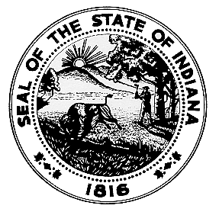STUDENT REGISTRATION FOR ILLEGAL DRUG LAB CLEANUP TRAINING
INDIANA STATE DEPARTMENT OF HEALTH
Environmental Public Health Division
100 North Senate Avenue IGCN 855
Indianapolis, Indiana 46204-2251
Telephone: (317) 234-1819
E-mail: druglabcleanup@ISDH.in.gov

State Form 55457 (R4 / 8-17)

INSTRUCTIONS: 1. Fill in all requested information using the check boxes and text fields provided.
2. Please submit this registration to the Indiana State Department of Health’s Environmental Public Health Division via e-mail
to druglabcleanup@ISDH.in.gov or by fax to (317) 233-7047.
3. If you have any questions, call (317) 234-1819.

TYPE OF TRAINING
Initial Refresher | Requested class date (month, day, year)

PERSONAL INFORMATION
Name

Name of company (if applicable)

Address (number and street including apartment, unit or room number, if applicable)

City or Town | State | ZIP Code
Telephone number with area code (office)  ( ) | Cellular number with area code  ( ) | Fax number with area code  ( )
E-mail address

SIGNATURE
Signature | Date signed (month, day, year)
Name (typed or printed) | Title (typed or printed)

