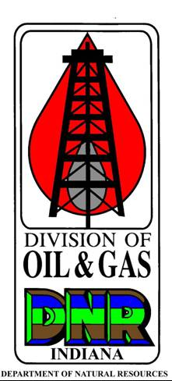 | PUBLIC NOTICE CERTIFICATION  FOR CLASS II WELLS  State Form 56499 (2-18)  INDIANA DEPARTMENT OF NATURAL RESOURCES  Division of Oil and Gas  402 W. Washington St., Rm. 293  Indianapolis, IN 46204  Telephone: (317) 232-4055  FAX: (317) 232-1550  Internet: http://www.in.gov/dnr/dnroil

I hereby certify that there are no persons entitled to notification of intent to obtain a Class II permit in accordance with the provisions of 312 IAC 29-5-2(a). Furthermore, I acknowledge that I shall place a notice of a permit application in a newspaper of general circulation in the county where the proposed well is located in accordance with the provisions of 312 IAC 29-5-2(c).

Date (month, day, year):
Signature

Printed Name

Title

NOTE: Only those individuals whose names appear in PARTS V or VI of the Organizational Report may sign this form.

