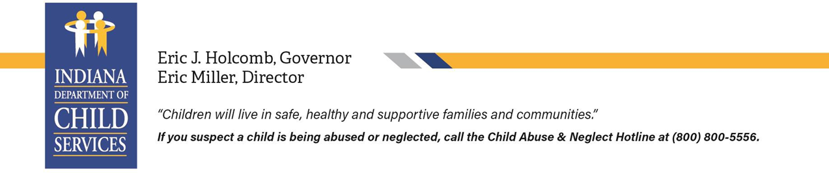

***Foster Care Verification Letter***

|  |
| --- |
|  |
| Pursuant to section to 475(5)(I) of the Family First Prevention Services Act (FFPSA) it is required to provide a youth in foster care for more than six (6) months official documentation necessary to verify their foster care status upon case closure at age (14) and older regardless of placement and legal status. |

**Re:** Name of Foster Youth **Date of Birth:** MM/DD/YYYY

**Date of Removal:** MM/DD/YYYY **End Date of Wardship:** MM/DD/YYYY

This letter serves as verification that [Youth's Name], date of birth [MM/DD/YYYY], was a “ward of the court”/Child in Needs of Services (CHINS), under the care and supervision of the Indiana Department of Child Services (DCS) and in foster care for at least six (6) months. This letter confirms that [Youth's Name] was considered a “ward of the court” for the purposes of verifying the youth previous foster care status.

|  |  |
| --- | --- |
| **Foster Care Verification Statement** | |
| **Check all that apply:** | |
|  | Free Application for Federal Student Aid (FAFSA) “ward of the court/in foster care” Eligibility. The above information provides verification for purposes of the FAFSA, and that the youth is/was “a dependent/ward of the court “any time on or after the age of thirteen (13).” |
|  |  |
|  | Eligible for the Education and Training Voucher Program. This statement verifies one of the following:   * Current “ward of the court” age sixteen (16) or older. * Aged out of foster care on or after the age of eighteen (18) or older. * Wardship dismissed due to adoption or guardianship at age sixteen (16) or older. |
|  |  |
|  | Eligible for Medicaid or other programs, services, and benefits for which being in foster care is an eligibility requirement due to aging out of foster care at age 18 or older. |

|  |  |  |  |  |
| --- | --- | --- | --- | --- |
| DCS Designee: | Printed Name | | | |
|  | |  |  | |
| DCS Designee: | Designee Signature |  | Date: | MM/DD/YYYY |

|  |
| --- |
| For youth transitioning out of foster care, this letter should be provided at age eighteen (18) and/or within ninety (90) days of wardship dismissal. For additional information or inquiries about services for former foster youth who aged out of foster care, contact Indiana Department of Child Services / Older Youth Initiatives at [OlderYouthQuestions@dcs.IN.gov](mailto:OlderYouthQuestions@dcs.IN.gov). |