HOOSIER RIVERWATCH WATER MONITORING EQUIPMENT APPLICATION
State Form 55220 (R2 / 2-17)
INDIANA DEPARTMENT OF ENVIRONMENTAL MANAGEMENT

Hoosier Riverwatch is Indiana’s statewide volunteer stream monitoring and education program. It is operated by the Indiana Department of Environmental Management with federal 319 funding. Our mission is to involve the citizens of Indiana in becoming active stewards of Indiana’s water resources through watershed education, water monitoring, and clean-up activities.
We accomplish this mission through the following goals:
- Educate citizens on watersheds and the relationship between land use and water quality.
- Train citizens on the basic principles of water quality monitoring.
- Promote opportunities for involvement in water quality issues.
- Provide water quality information to individuals and groups working to protect water resources.
- Support volunteer efforts through technical assistance, monitoring equipment, networking opportunities and education materials.
Hoosier Riverwatch has provided Equipment since 2001 to eligible groups. The combined Chemical and Biological packages are valued at nearly $500 worth of equipment and supplies.

ELIGIBILITY
Equipment recipients must meet the following criteria:
- Be affiliated with a non-profit organization, school, or government agency
- Agree to the Cooperative Agreement (page 4), including:
    - Attend a Basic Training Workshop (Must be registered for an upcoming workshop upon submission of application.)
    - Monitor and submit data online at least four (4) times per year for two (2) years (Total of eight (8) data sets by the end of the year following receipt of equipment)
- Return the completed Equipment Application between March and September of each year.

NOTE: Applications are processed on a rolling basis. Equipment Packages available beginning in March of each year. The award process is competitive, so please complete your application in detail so that we may fully assess your organization’s suitability as a recipient.

APPLICATION CHECKLIST
Thoroughly read Equipment Package Application.
Complete pages 3 and 4 - with all required signatures.
If you are part of a non-profit organization, please attach Articles of Incorporation.
Return completed documents to Hoosier Riverwatch Coordinator at
riverwatch@idem.in.gov.

CHEMICAL TESTING PACKAGE
CHEMetrics® Dissolved oxygen kit Tape measure
CHEMetrics® Orthophosphate kit Plastic egg or bobber
WaterWorksTM test strips for pH Stop watch
WaterWorksTM test strips for nitrates/nitrites Clipboard
Thermometer Pencils w/ sharpener
Transparency tube Ruler
BOD bottles Gear bag

BIOLOGICAL MONITORING PACKAGE
Kick net with poles Ice cube tray
Dip net with 4’ handle Plastic baster
Golden Guide’s Pond Life book Aquarium net
Two (2) bug magnifying cubes Forceps
One (1) two-way bug viewer Droppers
Dishpan Plastic spoons
Set of color macroinvertebrate identification cards Tote bag

BOTH CHEMICAL TESTING PACKAGE AND BIOLOGICAL MONITORING PACKAGE
- All of the above listed items.

Applications are accepted and processed from
March through September each year.

APPLICATION

BASIC INFORMATION
Name

Address (number and street)

City, State, and ZIP Code | County
E-mail Address | Telephone Number
Date Trained (month, day, year) / Location (if applicable)

ORGANIZATION INFORMATION
Name of Organization

Director / Principal / President

Address (number and street)

City, State, and ZIP Code | County
E-mail Address | Telephone Number

Which equipment package are you interested in receiving (refer to page 2 for descriptions)?
Both Chemical and Biological Chemical only Biological only
(most applicants will select this option)
What are the goals of your monitoring efforts (e.g. education, pollution identification…)?
How will your organization and surrounding community benefit from your monitoring?

COOPERATIVE AGREEMENT
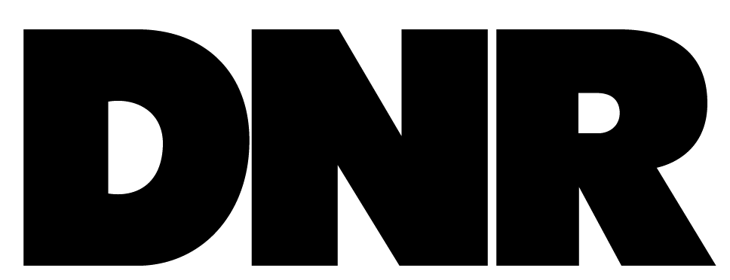
Between Hoosier Riverwatch of the Indiana Department of Environmental Management and
Equipment Packages
- 4 -
Hoosier Riverwatch • Fort Harrison State Park-NREC • 5785 Glenn Rd • Indianapolis, IN 46216 • 317.541.0617 • 317.562.9070 fax • riverinfo@dnr.in.gov
(Please fill in Organization’s complete name.)
This Cooperative Agreement is made and entered into by Hoosier Riverwatch and the organization written above to identify responsibilities, expectations, duties, and procedures related to the awarding of water quality monitoring equipment to eligible organizations in the State of Indiana. The awarding of such equipment supports the primary goal of Hoosier Riverwatch to increase public awareness of water quality issues by training volunteers in stream monitoring and environmental stewardship activities.
In accordance with this Cooperative Agreement, the Equipment Package Recipient shall:
Attend a Hoosier Riverwatch Basic Workshop before receiving an Equipment Package (applicants may apply for Equipment prior to attending a workshop).
Work with Hoosier Riverwatch to make arrangements to obtain the equipment.
Select one or more river/stream site(s) for regular water quality monitoring.
Monitor and submit at least eight (8) data sets to the online database, www.HoosierRiverwatch.com, prior to December 31st of the year following receipt of your
equipment (recipients typically submit datasets four (4) times per year for two (2) years).
Maintain equipment. Order refill chemicals and replacement supplies from Hoosier Riverwatch if needed.
Please note: Hoosier Riverwatch reserves the right to deny any refill request if the recipient organization is not actively monitoring, submitting data online, and/or utilizing Hoosier Riverwatch equipment.
Arrange for the return of the equipment if for any reason the equipment recipient cannot satisfy these terms during the two (2) year agreement period. The primary contact is responsible for contacting Hoosier Riverwatch with new contact information or to return the equipment if moving, changing jobs, or quitting the program!
In accordance with this Cooperative Agreement, Hoosier Riverwatch shall:
Provide introductory and advanced training workshops in water monitoring.
Serve as manager for the statewide Volunteer Stream Monitoring Internet Database – online at www.HoosierRiverwatch.com.
Act as a source for on-going consultation and support.
Signatures
This document outlines the terms of the Cooperative Agreement. Failure of the recipient to meet the terms listed above will result in the return of all equipment. By signing/typing below both parties accept the terms of this agreement:
Director/Principal/President – Date (month, day, year) | Primary Contact – Date (month, day, year)
For HRW use:
______________________________________ ______________
Hoosier Riverwatch Coordinator Date

