 | INDIANA CLEAN BOATER PLEDGE  State Form 53581 (R3 / 9-21) | 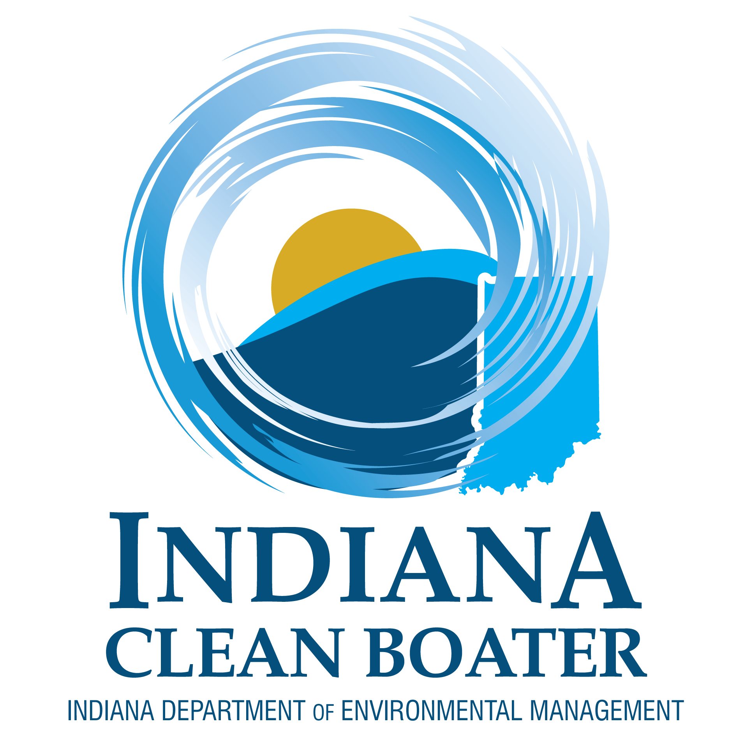  Indiana Department of Environmental Management  Clean Marina Program  100 North Senate Avenue, IGCN 1316  Indianapolis, IN 46204  Telephone: (800) 988-7901  E-mail: cleanmarinaprogram@idem.IN.gov
INSTRUCTIONS: 1. Read and complete this form.
2. Mail or e-mail to the above address.

As a recreational boater supportive of the Indiana Clean Marina Program, I pledge to be a steward of Indiana’s waters. I will read the Clean Boater Tip Sheets and use the recommended best management practices to protect our aquatic resources. I will further ensure all passengers aboard my watercraft follow these best management practices, and I will encourage other boaters to be stewards of Indiana’s waters as well.
Specifically, as an Indiana Clean Boater, I pledge to do my part to:
- Keep our waters free of litter by recycling or properly disposing of trash;
- Prevent spills of fuel and engine fluids by adopting proper watercraft fueling and maintenance practices;
- Stop the spread of aquatic invasive species by using Clean, Drain, Dry;
- Prevent discharges of sewage by using restrooms, pump outs, and dump stations;
- Protect sensitive shallow water habitats by obeying no-wake zones;
- Minimize other adverse impacts to the environment, including cleaning and winterizing my watercraft in an environmentally sensitive manner;
- Support the Clean Marina Program, including utilizing designated Clean Marinas when practical; and
- Serve as a Clean Boating ambassador to my passengers and other recreational boaters.

Questions marked with a * are required.

*1. | First Name of Recreational Boater

*2. | Last Name of Recreational Boater

3. | Mailing Address (number and street). Please provide if you would like to receive an Indiana Clean Boater Decal.

*4. | City

5. | State

*6. | ZIP Code

*7. | E-mail Address

8. | Telephone Number

9. | Favorite Marina or Body of Water

10. | City of Favorite Marina or Body of Water

