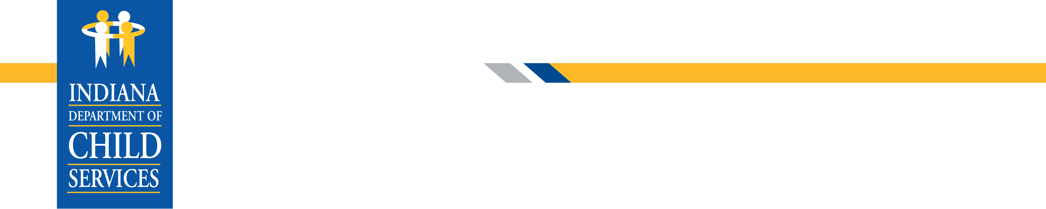
Mike Braun, Governor
Adam J. Krupp, Director
“Children will live in safe, healthy and supportive families and communities.”
If you suspect a child is being abused or neglected, call the Child Abuse & Neglect Hotline at 800-800-5556.
INDIANA DEPARTMENT OF CHILD SERVICES (DCS)
HOSPITAL RELEASE AUTHORIZATION

TO: Insert Hospital Name Hospital

FROM: DCS Local Office in Insert County County

RE: Insert Child's Name

Date: Insert Date

The Indiana Department of Child Services (DCS), pursuant to Indiana Code 31-33-11-1(b) confirms its authorization to release the above child.
(Please check below only that which applies.)

DCS authorized release of the above-named child to Insert Name.

DCS provided verbal authorization for the release of the above-named child to Insert Name on Insert Date.

DCS notified the above hospital of the court’s order to release said child (copy attached).

DCS did not authorize release until Insert Date due to:

Insert Reason.

Indiana Department of Child Services, local office in Insert County County by:

___________________________________________
Signature of Family Case Manager (FCM) Supervisor

___________________________________________________________
Printed Name
Date (month, day, year)

