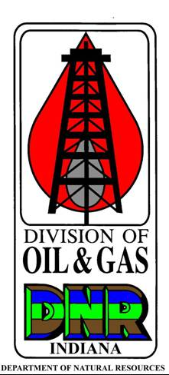 | FINAL REPORT OF LAND FARMING  OF WATER BASED DRILLING AND  COMPLETION WASTES ON AN  ALTERNATE SITE  State Form 56437 (12-17)  INDIANA DEPARTMENT OF NATURAL RESOURCES  Division of Oil and Gas  402 W. Washington St., Rm. 293  Indianapolis, IN 46204  Telephone number: (317) 232-4055  FAX number: (317) 232-1550  Internet: http://www.in.gov/dnr/dnroil

PART I GENERAL INFORMATION
Name of Operator |  |  |  |  |  |  | Telephone number  - -
Address of Operator (number and street) ( Check here if this is a new address.) |  |  |  |  |  |  | E-mail address
City |  |  |  |  |  |  | State | ZIP code  -
PART II WASTE DISPOSABLE LAND FARMING INFORMATION
Name of Landowner

Address of Landowner (number and street)

City |  |  |  |  |  |  | State | ZIP code  -
Township | Range | Land Type  Land Number: | ¼ | ¼ |  | ¼ | County
Type of Waste disposed

Amount of Waste disposed |  |  |  |  | Permit number where waste was generated
I affirm under the penalty for perjury that the foregoing is true to the best of our knowledge and belief, that the land farming process has been completed, and that I have complied with all provisions related to land farming found in 312 IAC 29-21-4.
Printed name of Operator or Authorized Agent

Signature of Operator or Authorized Agent |  |  |  |  |  |  | Date signed (month, day, year)

General Instructions

Use a 1"=100' scale
- Clearly indicate the section township, and range on the survey.

Operator or authorized agent must complete the following.
- Outline the boundary of the following:
- All water wells within 100’ of application area
- Streams, ponds lakes or surface water bodies within 100’ of the application area
- Property lines

N

T

N
or
S

R E or W

SPECIAL REQUIREMENTS

- A map or diagram showing the proposed application area and a demonstration that the site meets the requirements of 312 IAC 29-21-4 must be included with this application.
- Only those persons whose names appear in PARTS V or VI of the Organizational Report may sign this form as the operator
- The signatures of the operator, landowner, and inspector must appear on this form before the Application to Land Apply completion wastes will be accepted.
- The waste fluids or cuttings shall not be applied until authorized by the division.
- The land application site cannot be located within one hundred (100) feet of any water well, stream, pond, lake or other surface water body
- The land application site cannot be located within fifth (50) of any unleased property line.
- The operator is required to file with the division a report within thirty (30) days following the conclusion of the land farming operations which shall include a map or diagram showing the location of the area of land used for the land application and the total volume of waste disposed of at this location.

SPECIAL REQUIREMENTS

- A map or diagram showing the final application area must be included with this report.
- Only those persons whose names appear in PARTS V or VI of the Organizational Report may sign this form as the operator.

