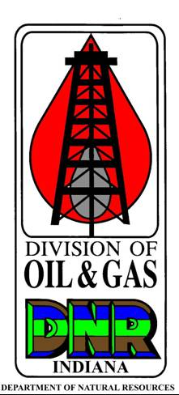 |  | ABANDONMENT CERTIFICATION REPORT  State Form 54873 (R / 12-17) / Form No. R13  INDIANA DEPARTMENT OF NATURAL RESOURCES  Division of Oil and Gas  402 W. Washington St., Rm. 293  Indianapolis, IN 46204  Telephone number: (317) 232-4055  FAX number: (317) 232-1550  Internet: http://www.in.gov/dnr/dnroil
PART I GENERAL INFORMATION
Name of operator |  |  |  |  | Telephone number  - - |  |  |  |  | Permit Number
Address of operator (number and street) |  |  |  |  |  |  |  |  |  | E-mail address
City |  |  |  |  |  |  |  | State |  |  |  |  |  | ZIP code
PART II WELL INFORMATION
Name of Lease |  |  |  |  |  | Well Number |  |  | Well Type |  |  |  | Date Plugged (month, day, year)
Township | Range |  | Section | Quarters |  | Footage’s | Footage’s |  |  |  | County
PART III ABANDONMENT CERTIFICATION
Site Release Checklist
Excavations filled Equipment / Debris removed Top 3’ of casing removed Site Leveled
Landowners Assumption of Responsibility  Excavations Equipment Converted to water well  Other (specify) |  |  |  |  |  |  |  |  |  |  |  | Signature of Landowner
Note: For any box left unchecked under the Site Release Checklist, the corresponding box under Landowner Assumption of Responsibility
must be checked and the landowner must sign above.
Printed name of Oil and Gas Inspector |  |  |  |  |  |  |  |  |  |  |  |  | Date released (month, day, year)
Signature of Oil and Gas Inspector

I, the above signed, certify that this well has been abandoned in accordance with the provisions of IC 14-37-8 and 312 IAC 29-33-24.

